PRESIDENT
AARON LAUTH
CHIEF OF POLICE
CARNEGIE MELLON UNIVERSITY

WESTERN PENNSYLVANIA
CHIEFS’ OF POLICE ASSOCIATION
Secretary, 2256 Watchfield Dr South Park, Pa 15129
Cell: 412-292-4096
e-mail:dmcd116@verizon.net • Website: www.westernpachiefs.org

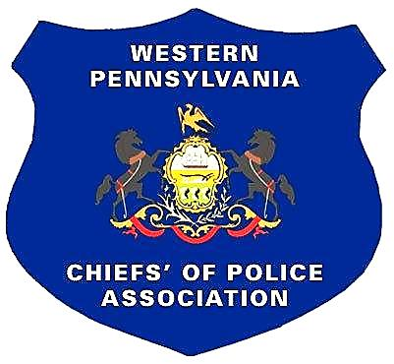
TREASURER
DONALD R. DOLFI
CHIEF OF POLICE- RET.
WHITEHALL BOROUGH

COUNSEL
MICHAEL COLARUSSO
428 BOULEVARD OF THE ALLIES
PITTSBURGH, PA 15219

FIRST VICE PRESIDENT
JON WHARTON
CHIEF OF POLICE
UPPER ST CLAIR TOWNSHIP

SECOND VICE PRESIDENT
JOHN SICILIA
CHIEF OF POLICE
NORTHERN REGIONAL

THIRD VICE PRESIDENT
SEAN FRANK
CHIEF OF POLICE
SHALER TOWNSHIP

SECRETARY
DENNIS MCDONOUGH
CHIEF OF POLICE
SOUTH PARK TWP

SERGEANT-AT-ARMS
WILLIAM L. ECKERT
CHIEF OF POLICE ASPINWALL-RET. BOROUGH

CHAPLAIN
JOHN ENGLISH
CHIEF OF POLICE
EDGEWORTH BOROUGH

The Western Pennsylvania Chiefs’ of Police Association, representing 21 counties in Western Pennsylvania, is hosting its 19th annual golf outing on Friday, August 4, 2023 at the Pittsburgh North Golf Club in Gibsonia, Pennsylvania. We sincerely appreciate your support of the Association and participation in our event.
The money that is raised from the golf outing is used to supplement the association and its budget, offering us the ability to provide in-service law enforcement training for our members and the opportunity to promote legislation that furthers the interests of law enforcement.
The day of golf, food, beverage and fellowship is a fun experience for everyone involved. The members of the Western Pennsylvania Chiefs’ of Police Association hope to see you at our event and thank you for your continued support of the Association’s efforts to improve law enforcement through education.
Attached you will find a sponsor’s sign-up sheet. There are several levels of support for you to consider including:
Platinum Sponsor: $2,500.00 - Golf Outing Naming Rights: Your Company’s information on an 8’X 46” banner, a one-year link of the Western Pennsylvania Chiefs’ of Police Website, a 36”X24” tee sign and a foursome in the golf event
Gold Sponsor: $1,100.00 - Your Company’s information on a 6’X 34” banner, a six-month link of the Western Pennsylvania Chiefs’ on Police Website, a 36”X24” tee sign and a foursome in the golf event.
Silver Sponsor: $650.00 - Your Company’s information on a 4’X 22” banner, a 24” X 18” tee sign and a foursome in the golf event.
Bronze Sponsor: $250.00 - Your Company’s logo on a 36” X 24” tee sign
Tee Sponsor: $100.00 - Your Company’s logo on a 24”X 18” tee sign
Gift Sponsor: Donation

Sincerely,
Mike Vogel
Chief Mike Vogel, Event Chairman - 412-292-4586 mvogel@achousing.org

Western Pennsylvania Chiefs’ of Police Association

